**Mini-Sentinel Distributed Query Tool**

**DataMart Administrator Manual**

**Powered by PopMedNetTM**

Based on release 3.2

June 2013

**CONTACTS:**

Jeffrey Brown, PhD

Harvard Pilgrim Health Care Institute

[Jeff_brown@hphc.org](mailto:Jeff_brown@hphc.org)

The **PopMedNetTM** application was developed under Contract No. 290-05-0033 from the Agency for Healthcare Research and Quality, US Department of Health and Human Services as part of the Developing Evidence to Inform Decisions about Effectiveness (DEcIDE) program, awarded to the DEcIDE centers at the HMO Research Network Center for Education and Research on Therapeutics (HMORN CERT) and the University of Pennsylvania. The Food and Drug Administration’s Mini-Sentinel project (Contract No. HHSF223200910006I) provided additional support

Contents

**1** Introduction 1

**2** System Overview 2

**3** How to Login to the Web Portal 4

**4** Configuring the DataMart Client 5

4.1 Installing the DataMart Client 5

4.2 Installing the Database (DataMart) 9

4.3 Creating an ODBC Connection 9

4.4 Configuring your DataMart Client Network Connection 12

4.5 Configure Your DataMarts 16

4.5.1 Summary Query Model Processor Settings 17

4.6 Configuring your DataMart Unattended Operations 19

**5** Processing Queries 22

5.1 Displaying the Request List 22

5.1.1 Filtering Options 24

5.1.2 Viewing Query Details 25

5.2 Executing and Uploading Queries 28

5.3 Holding Queries 29

5.4 Rejecting Queries 29

**6** Administering Your DataMart 30

6.1 Running Metadata Refresh Dates Queries 30

6.2 Creating an Audit Report for Your DataMart 33

**7** Administering or Changing your User Profile 36

7.1 Contact Information 36

7.2 Security Group Membership 36

7.3 Changing your Password 37

7.4 Receiving Notifications 38

7.4.1 Notification Event Reference 39

**8** Getting Help 42

8.1 Development and Funding Statement 42

8.2 Frequently Asked Questions 43

**9** Uninstalling the DataMart Client 44

**Document History**

The following table is a revision history for this document.

Table : Document History

|  |  |  |  |
| --- | --- | --- | --- |
| **Version** | **Author(s)** | **Date** | **Description** |
| 3.1 | Lincoln Peak Partners | 11/15/2012 | Created. |
| 3.2 | Jeff Brown, Elizabeth Balaconis, Megan Mazza, Melanie Davies | 5/13/2013 | New Build. This new documentation represents a new release of the PMN software. Prior Mini-Sentinel query tool documentation was based on release 2.3.24 and this documentation is based on PMN 3.2.0. New features include User Registration, Plug-in Architecture, Security Group Access Control, and Projects. |

# Introduction

The Mini-Sentinel Distributed Query Tool is based on the PopMedNet™ software application that enables simple, efficient creation and use of distributed data networks, through a set of tools and web-based services. It is optimized to facilitate distributed analyses of medical product safety, comparative effectiveness, quality, medical resource utilization, cost-effectiveness, and related studies. The system provides secure, customized private portals, query tools, and file transfer capabilities. It supports both menu driven queries and distributed analyses using complex, single use or multi-use programs designed to execute against a local data resource.

Data partners exercise full control over the files they make available for querying, the results returned to requestors, and the individuals who are permitted to submit queries.

This Mini-Sentinel DataMart Administrators Manual describes the main features and functions for DataMart Administrators participating in the network. DataMart Administrators will interact with the network through a secure web-based Portal and through the desktop DataMart Client as described below. This document is based on the version 3.x implementation of the PopMedNet™ system.

The Department of Population Medicine at the Harvard Pilgrim Health Care Institute (HPHCI) led development of the system in collaboration with Lincoln Peak Partners (LPP). Lincoln Peak Partners provides support services and secure hosting for current system users, and leads development of system enhancements.

# System Overview

The Mini-Sentinel Distributed Query Tool system is comprised of two separate applications, the web-based **Portal** and the **DataMart Client**. There is exactly one Portal in the network and each data partner has one or more “DataMarts”. The Portal is the starting point for all information requests and controls all system communications, security, and governance policies. Data Partnersreceive queries, process them, and securely return them to the Portal via their local DataMart Client. Each Mini-Sentinel Data Partner will have at least one DataMart; multiple DataMarts per Data Partner are possible. Each DataMart can contain different types of data and DataMarts can have different query processing settings. All query requests and communications within the network are securely routed from the Portal to the DataMarts and then back to the Portal.

**Note:** The term **DataMart** is used in an information technology context referring to the place where the data are held for querying. Use of this term does not imply that data partner information is being sold or being made broadly available; Data Partners maintain control of all their data and all uses.

**Browser Requirements**

The Portal is designed to work with Internet Explorer (IE) 8 or later. Earlier versions of IE may not display the user interface properly. Although IE8 is the only officially supported browser, other browsers such as Firefox and Chrome will also work. Firefox and Chrome have been used extensively during testing.

**The DataMart Client Application**

The DataMart Client application allows the DataMart Administrator to view queries distributed to the DataMart, execute queries locally, review the results, and upload the results to the Portal. The DataMart Client is a .NET/C# Windows desktop application developed by LPP that is installed locally on an Administrator’s desktop. Note the DataMart Client requires Microsoft .NET 4 to be installed on the user’s desktop. The free download for Microsoft .NET4 is available at the following link: <http://www.microsoft.com/enus/download/details.aspx?id=17851> All communications between the DataMart Client application and the Portal use HTTP/SSL/TLS connections to securely transfer queries and results between the application and the Portal. The application uses ODBC connections to the local DataMart databases used to process queries and generate results.

**Audience**

This manual is intended for Distributed Query Tool DataMart Administrators who want to:

* Install the DataMart Client
* Process queries distributed to the DataMart
* Administer DataMart settings
* Add DataMarts
* Manage and audit DataMarts

**Related Documents**

For more information about the PopMedNet™ system, see one of the following documents:

**Distributed Query Tool Investigator Manual**

The *Investigator Manual* describes the tasks and activities required for Investigators to:

* Get started accessing the PopMedNet™ Portal
* Submit a query to the available DataMarts
* Monitor status of a query
* Review results of a query

The Investigator Manual also describes the types of queries and the criteria required for submission of each query type.

**Distributed Query Tool Overview and Administrators Guide**

The *Overview and Administrator’s Guide* describes the overall network system architecture, key querying features, and hosting and security details. This includes:

* System overview and workflow
* Policies and features
* Installing an instance of a Portal and an associated database
* Performing the initial administrative setup
* Performing typical System Administrator functions such as adding new users and DataMarts, creating new roles, and deleting users and DataMarts
* Technical architecture and security
* Hosting Configurations

# How to Login to the Web Portal

Before you can login to your Website Portal, you need a username and password assigned by your Network Administrator. Once you have your Login Credentials, follow the steps below.

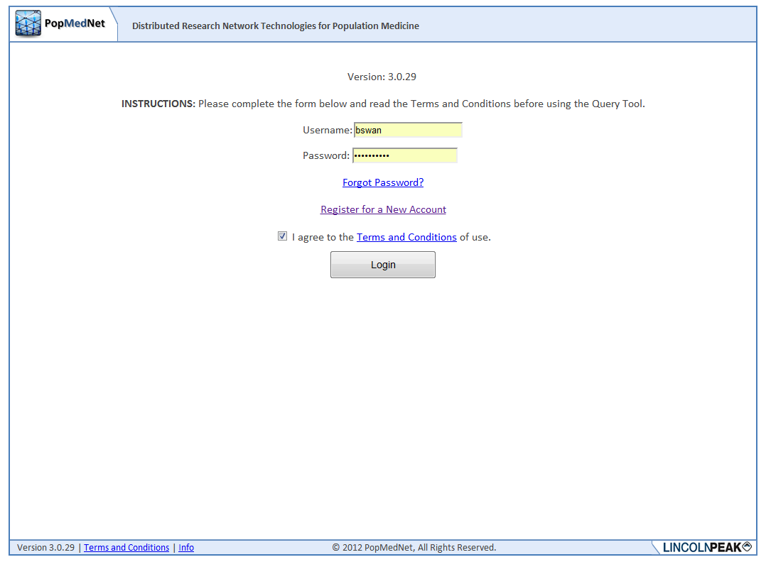

**Figure 1: Logon Page**

* 1. Navigate to the custom website login page:  
     [Secure URL distributed by network coordinating center]
  2. Enter your username and password in the boxes.
  3. If this is your first login, you will be prompted to read and acknowledge your agreement to the Terms and Conditions of use. If you have cookies enabled, you will not be prompted on subsequent logins.
  4. Click the Login button to enter the website Portal.

# Configuring the DataMart Client

This section describes the installation setup of the DataMart Client.

Your local computer user account must have administrative privileges to install the DataMart Client.

**Note:** You do not need to uninstall a prior version of the DataMart client when installing a new, upgraded version of this software, this happens automatically. If for any reason, you do need to uninstall the DataMart Client, see Section : Uninstalling the DataMart Client.

There are three basic steps to setting up the DataMart Client:

* Download and install the DataMart Client
* Create an ODBC Data Source Name (DSN) for your DataMart. **Note**: This will help link your DataMart Client with your DataMart. The DataMart is created separately.
* Configure the DataMart Client to point to your ODBC DSN (DataMart).

## Installing the DataMart Client

Use these steps to install the DataMart Client:

1. Login to the web Portal using your DataMart Administrator login credentials provided by the PopMedNet™ Support Staff.
2. Navigate to the DataMart list page (Network>DataMarts).

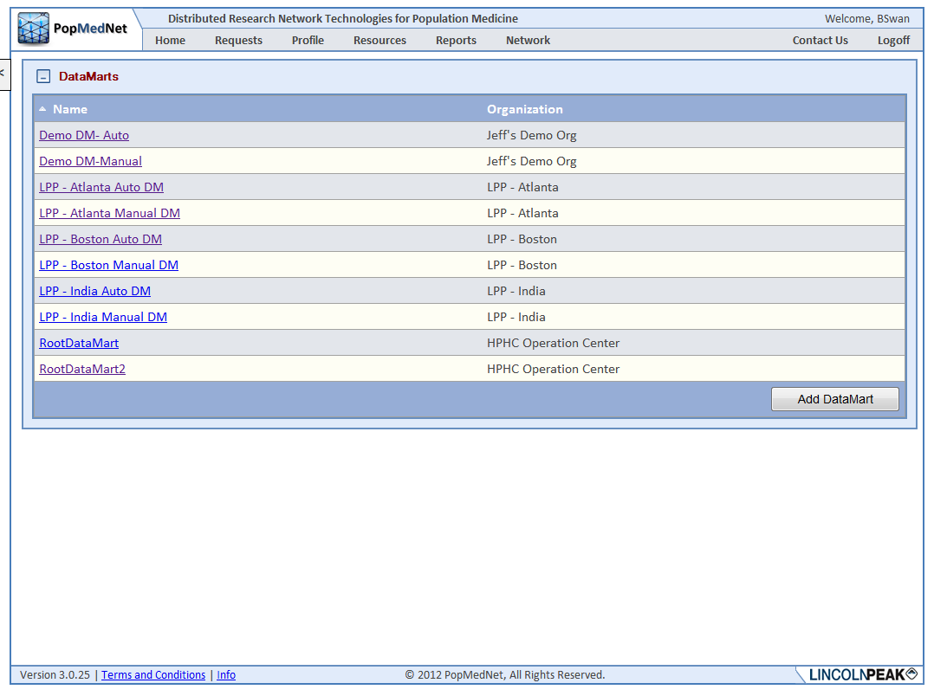

Figure : DataMarts Page

1. Click on your DataMart entry in the list to display the DataMart profile.

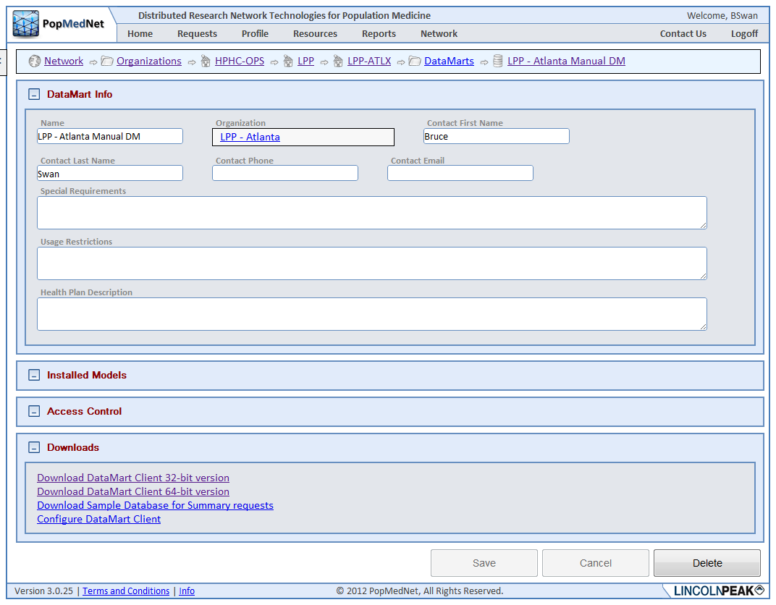

Figure : DataMart Profile Page

1. Click the Download button at the bottom of the page to download the DataMart Client setup. Note: Install the 32-bit or 64-bit version depending on your operating system.
2. When prompted, click Run:

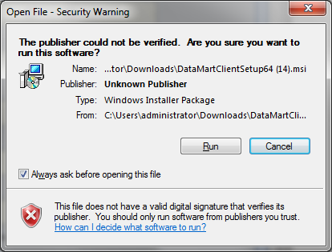

Figure : DataMart Client Setup Dialogue

1. Click Next to begin the Setup:

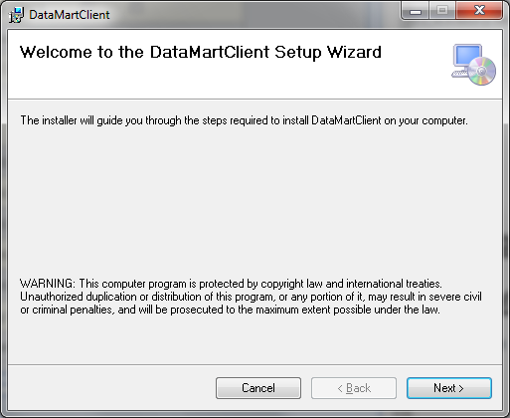

Figure : DataMart Client Setup Dialog

1. Select the installation folder then click Next:

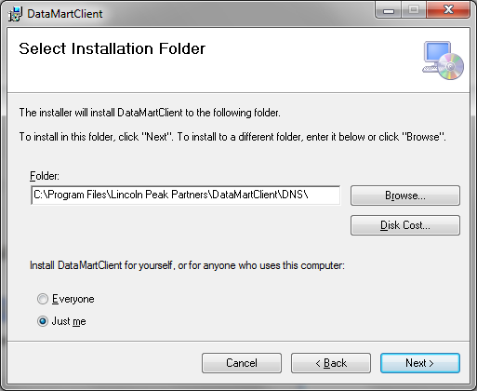

Figure : DataMart Client Setup Dialog

1. Click Next to confirm the installation:

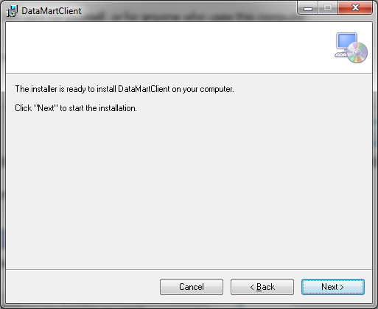

Figure : DataMart Client Setup Dialog

## Installing the Database (DataMart)

To connect a DataMart database to the DataMart Client, save the DataMart to the desired folder on your local computer or network. The DataMart database is usually a Microsoft Access database file that has an .mdb or .accdb file extension. Other database types for example, MySQL are supported. All DataMarts within your network are created separately under guidance of your Network Administrator.

Note: It is important to remember the folder (i.e., location) and file name of your saved database, as this will be required information when you establish your open database connectivity (ODBC) connection (i.e., connect your DataMart Client to your database location) – see the next section.

Also, for testing purposes, there is a sample summary table database (Demonstration Query Tool.mdb) available on the DataMart profile page. To download the sample database, click the download button at the bottom of the page. After you click the download button you will be prompted to save this file. The default name may be changed upon saving the file.

## Creating an ODBC Connection

Once you have installed the DataMart Client and your database, you must create an Open Database Connectivity (ODBC) connection to your data source.

Use these steps to create an ODBC connection:

1. Go to Settings>Control Panel > Administrative Tools > Data Sources (ODBC):

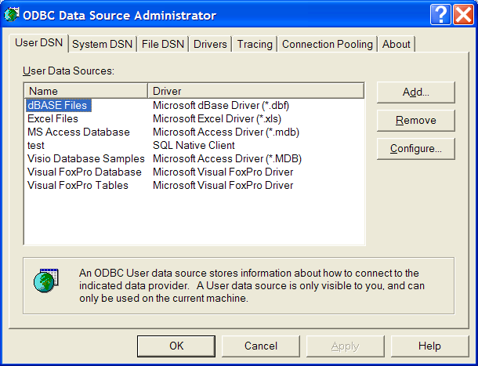

Figure : ODBC Data Source Administrator Dialog

1. Click on the System DSN tab and click the Add button.

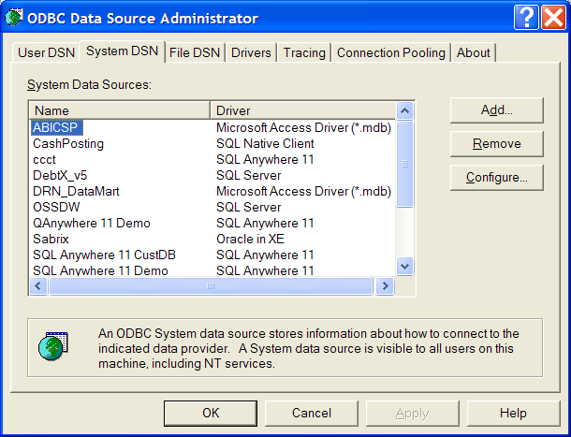

Figure : ODBC Data Source Administrator Dialog

1. In the Create New Data Source window, choose Microsoft Access Driver (*.mdb) and click Finish:

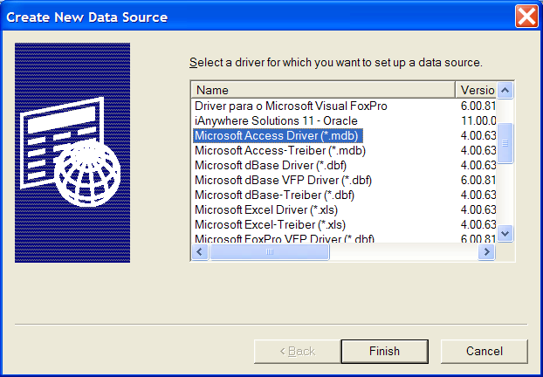

Figure : Create New Data Source Dialog

1. Enter the Data Source Name and locate the database:

a) Under Data Source Name, type the name of your data source, for example: **[Network Name] _SummaryTables.**

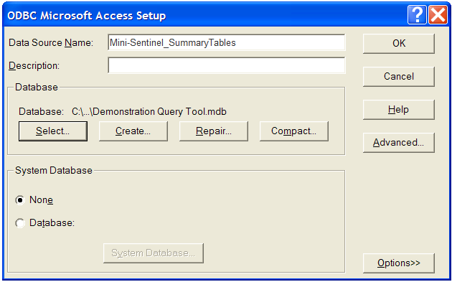

Figure : ODBC Microsoft Access Setup Dialog

b) Click the “Select” button to locate your database. Make sure to select your database from the folder that you saved it to in section 4.2 above. Click OK and then click OK again to save:

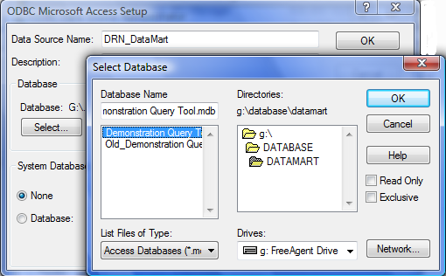

Figure : ODBC Microsoft Access Setup Dialog

## Configuring your DataMart Client Network Connection

The first time you launch the DataMart Client application you need to configure it to connect to the network Portal. The following form is displayed:

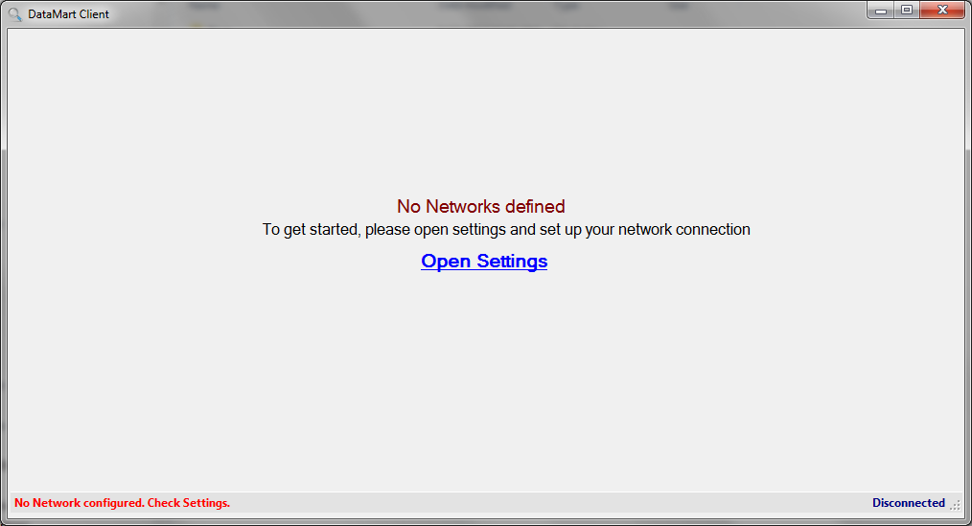

Figure : DataMart Client Launch Screen

1. Click the “Open Settings” link to display the Network List form. Note, if this is not your first DataMart Client launch, select the Settings button.

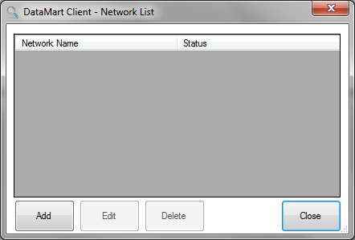

Figure : DataMart Client Network List Dialog

1. Click the “Add” button to enter the network connection settings:

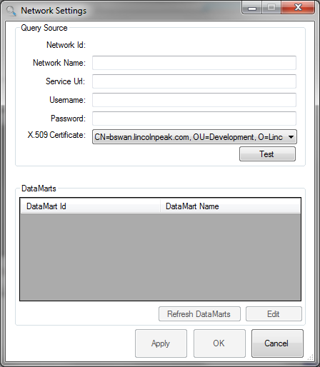

Figure : DataMart Client Network Settings Dialog

1. Enter a friendly network name and the network Portal web service URL in “Service URL” edit control that follows the following pattern:

https://querytool3.mini-sentinel.org/api/soap/dmclient

1. Next enter your username and password into the edit controls. If you’re using X.509 certificates to authenticate to the network, scroll through the list and choose the certificate you installed to access the PopMedNet network.
2. Now press “Test” button to test your connection information. You should see “Connection Successful” message box as follows:

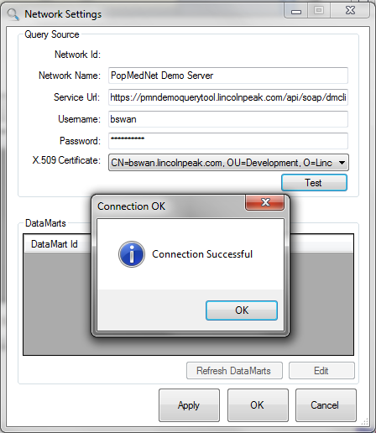

Figure : DataMart Client Network Settings – Connection Successful Message

*If the connection fails, see your Network Administrator for support.

1. Click the “OK” button on the message box to return to the Network Settings dialog box that will display the list of DataMarts you have rights to administer.

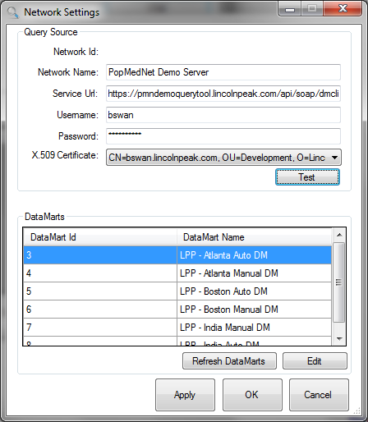

Figure : DataMart Client Network Settings – DataMarts Panel Dialog

1. Click the “Apply” button to save your connection settings and proceed to section 4.5 to configure your DataMart.

## Configure Your DataMarts

Now that you are connected to the network, you need to configure the settings for each of the DataMarts you’ve been granted privileges to administer. For each DataMart in the list, perform the following steps:

1. Double click the DataMart item in the list of DataMarts or select it and press “Edit”.

This action will display the DataMart Settings dialog as follows:

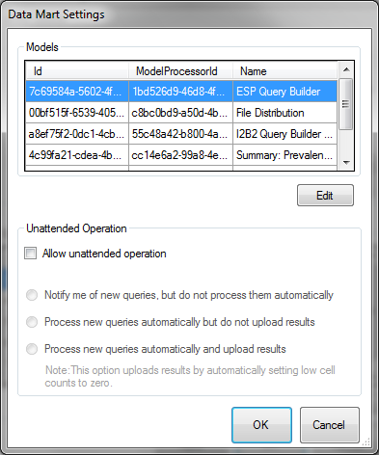

Figure : DataMart Client DataMart Settings Dialog

There are two sections that need to be configured. First, there is a list of “Models” that represent the various request model processors that are used to process queries issued to your DataMart.

For each item in the list, double click it or select it and press Edit and proceed to step 2 below.

1. Edit each Model Processor and configure settings

Each processor may have different properties that need to be set. The following sections describe these properties. Once this is done for all your model processors, proceed to section 4.6 Configure DataMart Unattended Operation.

### Summary Query Model Processor Settings

For Summary Query model processors (Summary: Prevalence Queries, Summary: Incidence Queries, and Summary: Most Frequently Used Queries), the following dialog will be displayed:

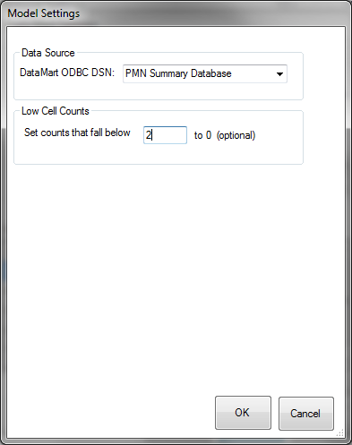

Figure : Summary Table Model Settings Dialog

Use the Data Source dropdown menu to select the DataMart name you created in Section (for example, [Network Name]_Summary Tables). This is the DataMart that will be used when queries are sent to the DataMart. Any number of additional DataMarts can be created to direct queries to other data resources.

The low cell count setting allows you to specify a cell count limit for results. This setting scans the query results for any individual cell that is less than the specified limit and highlights that row in yellow. You can then choose to upload the results without changing the low cells or click “Change Count” to change the relevant cells to zero before uploading. See the screenshot below for an example.

**Note**: **If you select “Process new queries automatically and upload results” in the Unattended Operation settings, results will be uploaded regardless of the low cell count setting.**

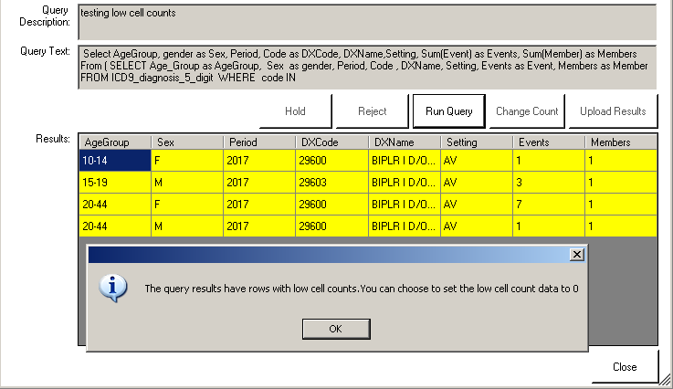

Figure : Request Response Low Cell Count Message

Press OK once you’ve entered the ODBC connection name and entered a value for the Low Cell Count threshold.

## Configuring your DataMart Unattended Operations

Now that the model processors have been configured, you need to configure your DataMart’s Unattended Operation settings. Once you have modified your settings, click OK to save and return the DataMart settings form:

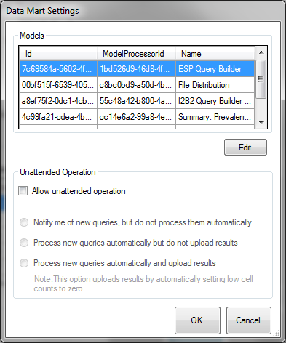

Figure : Unattended Operation Settings Dialog

The Unattended Operation settings allow the application to operate in a fully manual, semi-automated or fully automated query processing. If you select “Allow unattended operation”, unattended operation checks for new queries, and processes the queries according to the options you select. Users should minimize the application instead of logging out of the application so that automatic query processing takes place in the back ground - click ‘Close’ or minimize the Client from the Query List page.

Table : Unattended Operation Settings

| **Option** | **Description** |
| --- | --- |
| Notify me of new queries, but do not process them automatically | The DataMart Client checks for queries and notifies the DataMart Administrator via a pop-up notification in the System Tray above the DataMart Client icon. |
| Process new queries automatically but do not upload results | The DataMart Client checks for queries and processes the query automatically, but the DataMart Administrator must upload and review the query results manually. |
| Process new queries automatically and upload results | The DataMart Client checks for queries, processes the query automatically and uploads the results. This option does not require any DataMart Administrator intervention in the process. |

# Processing Queries

Once you have configured the DataMart Client, you are now ready to process all queries distributed to your DataMart. As DataMart Administrator, you have the rights to perform the following operations on a query:

* Execute and review results
* Hold a query
* Reject a query
* Change Cell Counts
* Upload Results

## Displaying the Request List

Once you are connected to the network, you will see the list of requests that have been routed to your DataMart(s). The following figure shows the main request list view:

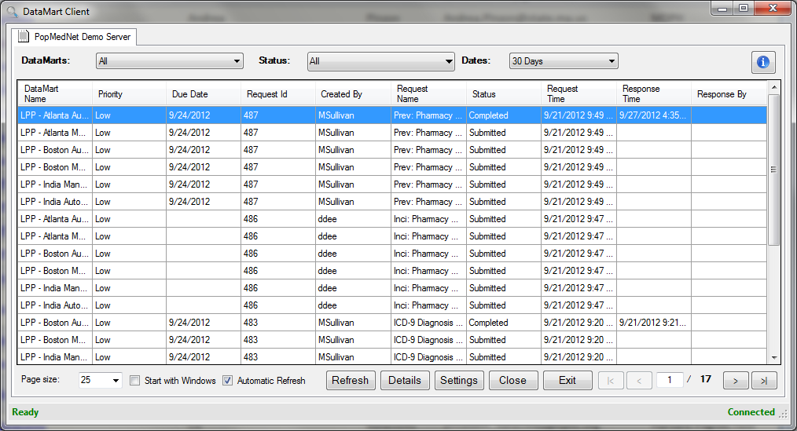

Figure : DataMart Client Request List Window

The request list displays the status of all queries across all Networks and DataMarts for which you are a DataMart Administrator. If you are connected to multiple PopMedNet networks, there will be multiple tabs at the top of the application allowing you to navigate each network to see its requests.

The request list may be refreshed automatically based on a timer by checking the “Automatic Refresh” control at the bottom of the window. Users can update on demand by clicking the “Refresh” button.

The user can adjust the number of requests displayed on a page via the “Page size” control in the lower left. On the lower right, there is a pages control to advance to the first, last, next, and previous pages.

You can filter the display by Network, DataMarts, and Query Status to show a subset of the queries submitted to your DataMarts. When you select a filtering option from the drop-down list, the Request List is refreshed automatically.

The “Settings” button will display the Network Settings dialog allowing the user to modify their network or DataMart settings.

The DataMart Client application can be started at Windows startup by checking the “Start with Windows” control.

There is a status panel along the bottom of the application that displays connection and status information for the application.

The user may completely exit and unload the program by clicking the “Exit” button. Clicking the “Close” button will cause the program to minimize itself and stay running. Launching the program again will restore the main request view. Additionally, clicking the DataMart Client icon in the system tray control will also restore the window.

Lastly, clicking the information control icon Image of the information icon from the DataMart Client will display the application “About” popup dialog that displays the version number that is installed and running.

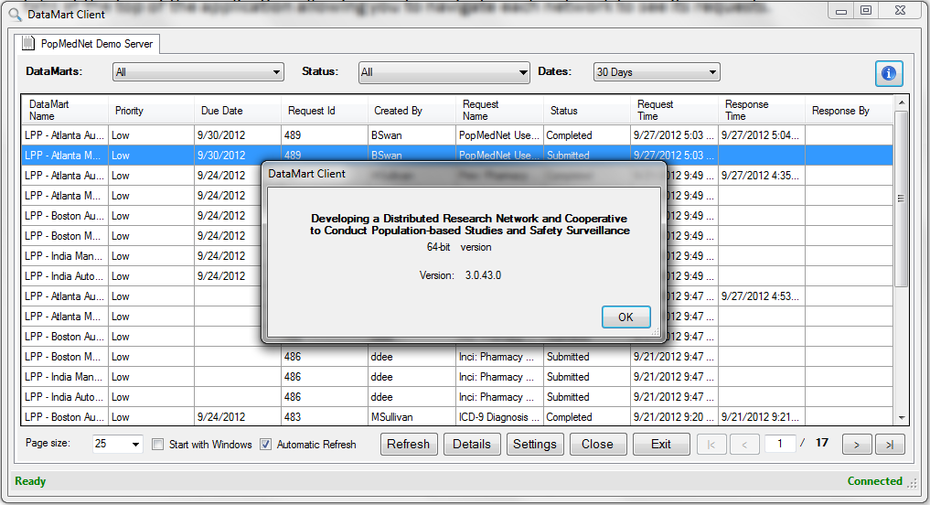

Figure : DataMart Client Information Message

### Filtering Options

Use the drop-down controls at the top of the screen or you may click on any column title to sort your list of queries (e.g., DataMart Name, Created By, Request Time, Status and Response Time). You can filter by the following:

Table : DataMart Client Filtering Options

|  |  |
| --- | --- |
| **Option** | **Description** |
| DataMarts | The DataMarts drop-down list displays the DataMarts that you are configured to administer within the selected Network(s) in addition to an “All” selection. Each network will have at least one DataMart. |
| Status | The Status drop-down list allows you to view queries by status: Pending, Submitted, Completed, Awaiting Approval, Rejected, Cancelled, Pending Group DataMart Administrator Approval, In Progress, or Failed in addition to an “All” selection. |
| Date | Go to File > Filter (or Ctrl + F). You can choose to filter the query list by preset time periods or by custom dates. |

#### Query Status

When viewing queries by status, you can sort on the following options.

**Note**: Running a query does not change the query’s status.

Table : DataMart Client Query Statuses

| **Status** | **Description** |
| --- | --- |
| All | Displays all queries. Does not filter by status. |
| Pending | The query has been submitted to the DataMart, but not yet processed by the background service (HubBackgroundService). Pending is an intermediate state, usually very short. Once the background service has processed the query, it changes the status to Submitted. |
| Submitted | The query has been submitted to the DataMart and processed by the background service. Submitted and Pending both mean that an Investigator has submitted a query. The only difference is that the intermediate state of Pending gets changed to Submitted by the background service that polls the database for new queries. If the query status does not get changed to Submitted, the background service is not working. |
| Completed | The results of the query have been uploaded to the Portal. Queries are marked Completed when results have been uploaded by the DataMart Administrator (via DataMart Client) or by the Server DataMart. |
| Awaiting Approval | The query has been received by the DataMart but requires approval from the DataMart Administrator before it is executed. The DataMart Administrator can set a query to Awaiting Approval by clicking the Hold button in the Query Detail view of the DataMart Client. See Section 5.3 . After further review, you may upload the queries you hold that are Awaiting Approval. |
| Rejected | The query has been rejected by the DataMart Administrator. The DataMart Administrator sets the query state to Rejected by clicking the Reject button in the Query Detail view of the DataMart Client. See Section 5.4 . Rejecting a query ends the life of the query submitted to that DataMart. |
| Cancelled | The Investigator has removed the DataMart from the query. Removing DataMarts from a query marks the status of the query for the removed DataMart as Cancelled. Note: The Investigator cannot remove a particular DataMart from the query after it has uploaded results. |
| Pending Group DataMart Administrator Approval | The query has been received by the DataMart but requires approval by the Group DataMart Administrator, if applicable. All results uploaded by DataMarts that are part of the Group’s organizations require this approval. The uploaded results are withheld from the Investigator unless approved by the Group DataMart Administrator. |
| In Progress | The query has been processed at the DataMart Client but uploading the results has not finished. For example, if you have selected “Process new queries automatically but do not upload results” in the DataMart Client settings, you might see the In Progress status. |
| Failed | The query encountered errors while processing or failed to upload results. |

### Viewing Query Details

Highlight an entry in the list and click the “Details” button to open the Request Detail view. You can also double-click an entry in the list.

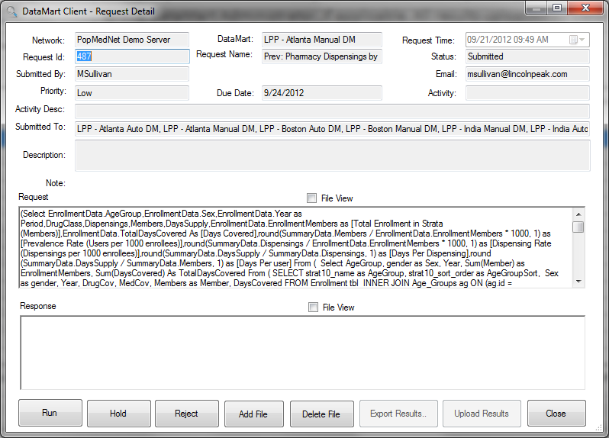

Figure : DataMart Client Request Detail Form

#### Query Result Parameters

Summary Table Parameters:

* Query Category: Prevalence (Prev), Incidence, Most Frequent Utilization (MFU)
* Query Types:
  + Enrollment
    - Drug and Medical Coverage
    - Medical Coverage Only
    - Drug Coverage Only
    - All Members (which represents a the union of previous 3 coverage types)
  + HCPCS (Healthcare Common Procedure Coding System)
  + ICD 9 Diagnoses (3 Digit Codes)
  + ICD 9 Diagnoses (4 Digit Codes)
  + ICD 9 Diagnoses (5 Digit Codes)
  + ICD 9 Procedures (3 Digit Codes)
  + ICD 9 Procedures (4 Digit Codes)
  + Pharmacy Dispensings by Generic Name
  + Pharmacy Dispensings by Drug Class
  + Incident ICD 9 Diagnoses (3 Digit Codes)
  + Incident Pharmacy Dispensings by Drug Class
  + Incident Pharmacy Dispensings by Generic Name
* Sex Stratifications:
  + Female: F
  + Male: M
  + Male and Female Aggregated: All
* Age Stratifications:
  + 10 Stratifications: 0-1 years, 2-4, 5-9, 10-14, 15-18, 19-21, 22-44, 45-64, 65-74, 75+
  + 7 Stratifications: 0-4, 5-9, 10-18, 19-21, 22-44, 45-64, 65+
  + 4 Stratifications: 0-21, 22-44, 45-64, 65+
  + 2 Stratifications: Under 65, 65+
  + 0 Stratifications: 0+
* Settings (only applicable for medical queries):
  + AV: Outpatient
  + IP: Inpatient
  + ED: Emergency Department
  + AN: Any Setting
* Periods: Yearly, depending on the availability within your database. Pharmacy Dispensings queries have quarterly availability.
* Calculated Columns
  + Medical Queries: HCPCS Procedures, ICD-9 Diagnoses and Procedures
    - Total Enrollment in Strata (Members)-Total count includes members with both medical and drug coverage plus those with medical coverage only.
    - Days covered
    - Prevalence Rates (Users per 1000 enrollees)
    - Event Rate (Events per 1000 enrollees)
    - Events per Member
  + Drug Queries: Pharmacy Dispensings by Generic Name and Drug Class
    - Total Enrollment in Strata (Members)- Total count includes members with both medical and drug coverage plus those with drug coverage only.
    - Days Covered
    - Prevalence Rates (Users per 1000 enrollees)
    - Dispensing Rate (Dispensings per 1000 enrollees)
    - Days per Dispensing
    - Days per user

## Executing and Uploading Queries

You can execute a query by clicking the “Run” button in the Request Detail view. This action will pull the query from the Portal to run against your selected data source. Results will be displayed in the Response window as shown below.

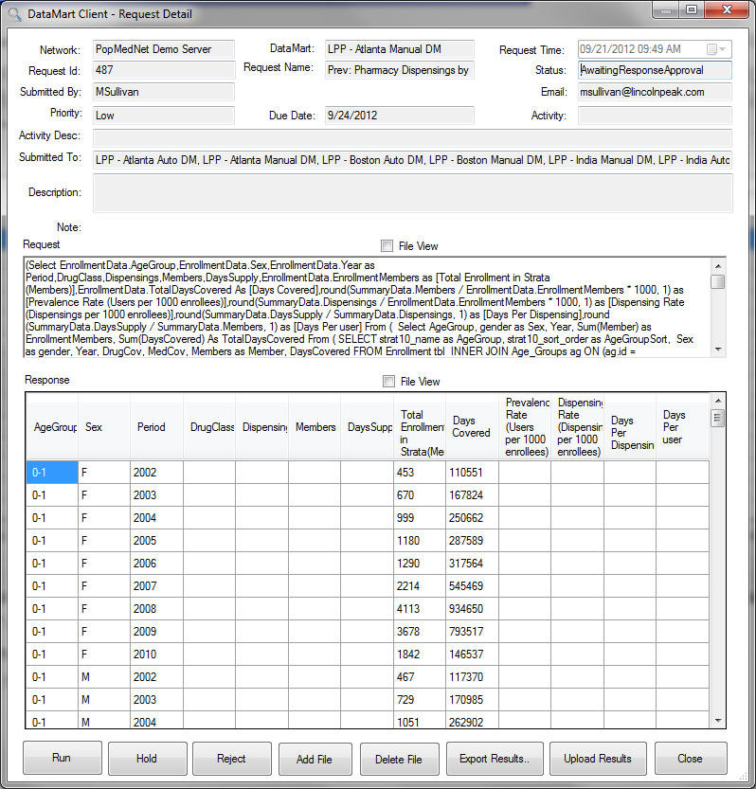

Figure : DataMart Client Request Detail Form with Response

Click on the “Upload Results” button to upload the results of the query to the Portal. You may leave a comment, as seen in the screenshot below, if you would like to provide additional information with your results. The query requestor will see these comments along with the results on the Portal.

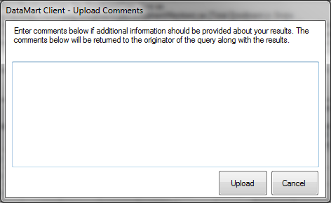

Figure : DataMart Client Response Upload Dialog

In the case of multiple DataMart Administrators for one DataMart, the ‘Upload Results’ button will grey out once one DataMart Administrator uploads results. After results have been uploaded, you may still review the results that have been uploaded by clicking Run Query. However, you will not have the option to upload the results again.

## Holding Queries

You can put a query on hold to notify the requestor that you have received/executed the query but have not yet uploaded results for it. To do this, click Hold in the Request Detail view and include comments, if necessary. The query status on the Portal will change from submitted to “Awaiting Approval” and any comments will be sent to the requestor. Depending on the approval, you may then upload results or reject the query.

## Rejecting Queries

Queries can be rejected before or after execution. To reject a query, click Reject in the Request Detail view. You have the option to provide a reason for the rejection. The query status on the Portal changes to Rejected and the reason is provided to the requestor.

# Administering Your DataMart

As the DataMart Administrator you can perform several tasks on your network’s Web Portal. These tasks are:

* Viewing overview information (metadata) about network DataMarts
* Managing your DataMarts, including running Metadata Refresh Dates queries
* Creating an audit report of the DataMart
* Submit queries to your own DataMart

## Running Metadata Refresh Dates Queries

Whenever a site refreshes its summary tables, a DataMart Administrator should complete metadata refresh dates queries for the prevalence, incidence, and most frequently used query types.

1. Log into the Query Tool Portal
2. Go to the Requests tab. Click “New” to create a new request.

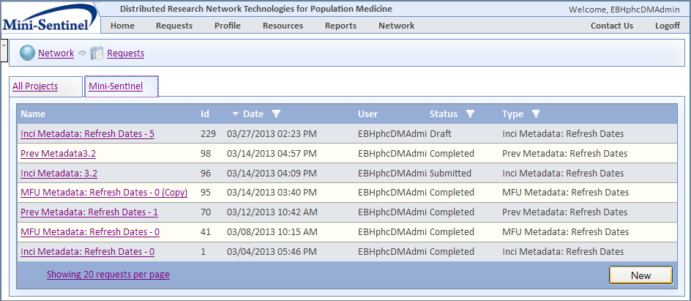

Figure : Requests Page

1. In the Choose Request Type window, select “Summary: Prevalence Queries”.
2. Click “Prev Metadata: Refresh Dates” to open the request form. 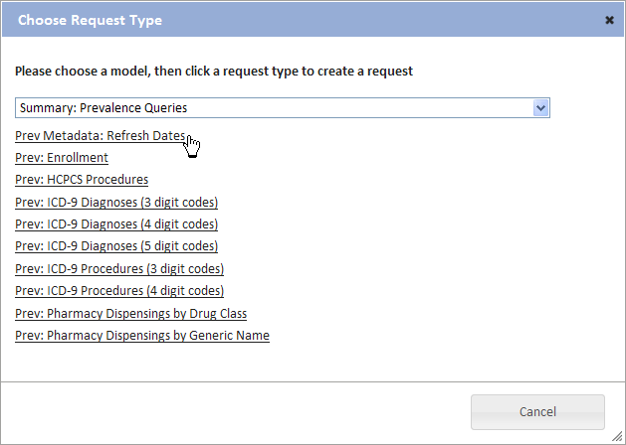

Figure : New Request Dialog

1. Check your DataMart(s) and click “Submit” to send the query to your DataMart Client.

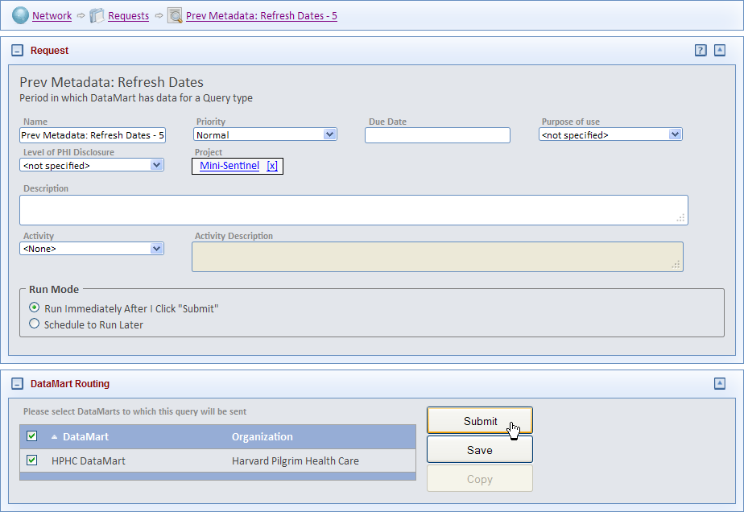

Figure : Request Composer Page

1. Open your desktop DataMart Client. Double-click the query when it appears in the query list to open the detailed view.

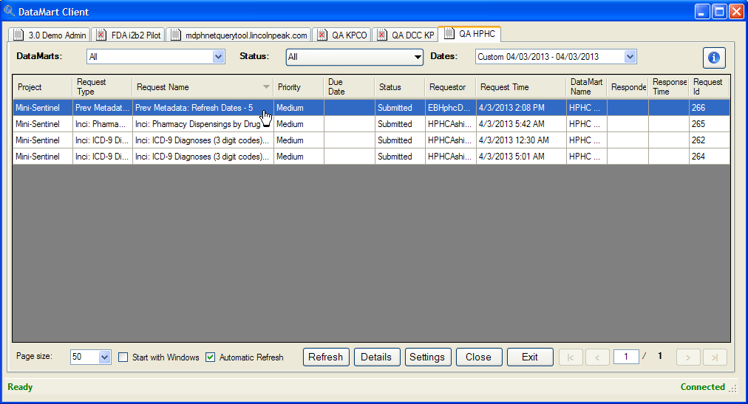

Figure : DataMart Client Requests List Window

1. Click “Run” to process the query. It may take several minutes to run. After the query has run, click “Upload Results” to send the results to the portal.

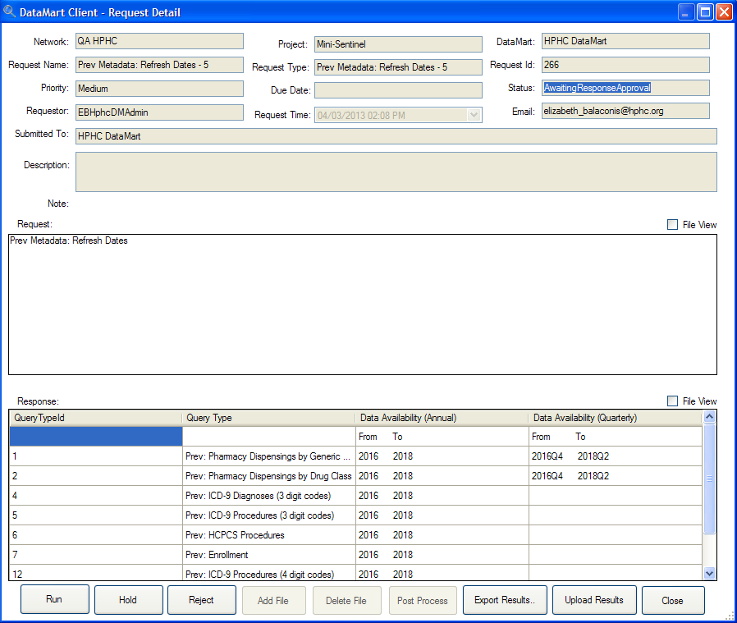

Figure : DataMart Client Request Detail Form – Holding or Uploading

1. Repeat steps 3-7 twice more, choosing “Summary: Incidence Queries” and “Summary: Most Frequently Used Queries” in step 3.

To see a summary of the data available on the network, go to the Resources tab and click on “Query Types by DataMart”.

## Creating an Audit Report for Your DataMart

The Audit Report allows you to view all the activity that has been requested from any of your DataMarts. Administrators may run an Audit Report for their DataMart in the Portal by navigating to Reports/DataMart Audit Report.

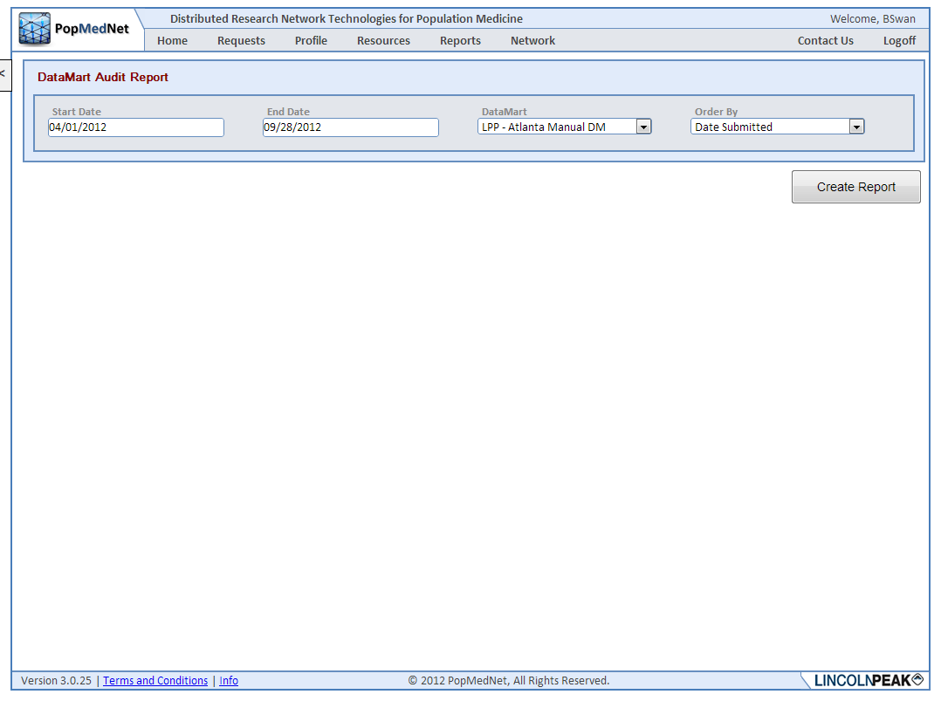

Figure : DataMart Audit Report Request Page

Select the start and end dates for your report, whether you want a summary or a detailed report, and how you want the data fields in the report to be ordered. The following figure shows a sample report.

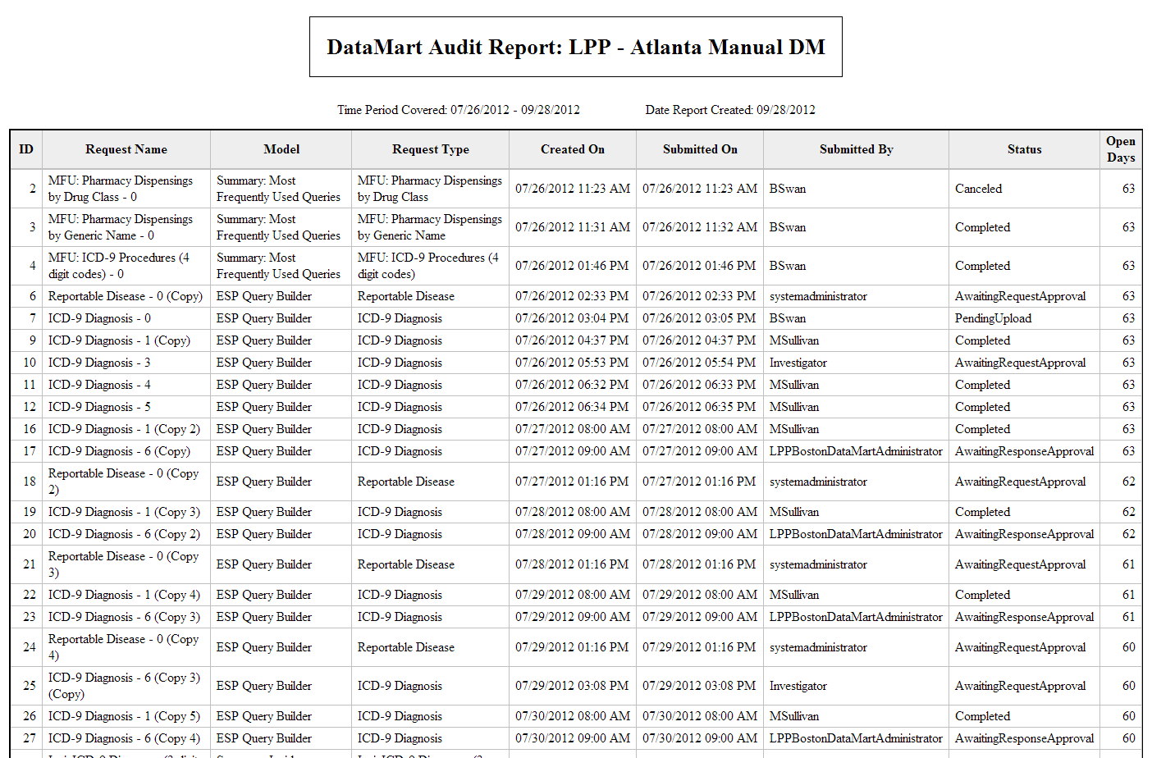

Figure : DataMart Audit Report

# Administering or Changing your User Profile

This section describes how to administer your user profile. You must be logged in to the web Portal to administer your user profile. Click Profile menu to view your account information.

## Contact Information

You can enter or update your information in the Contact Information panel.

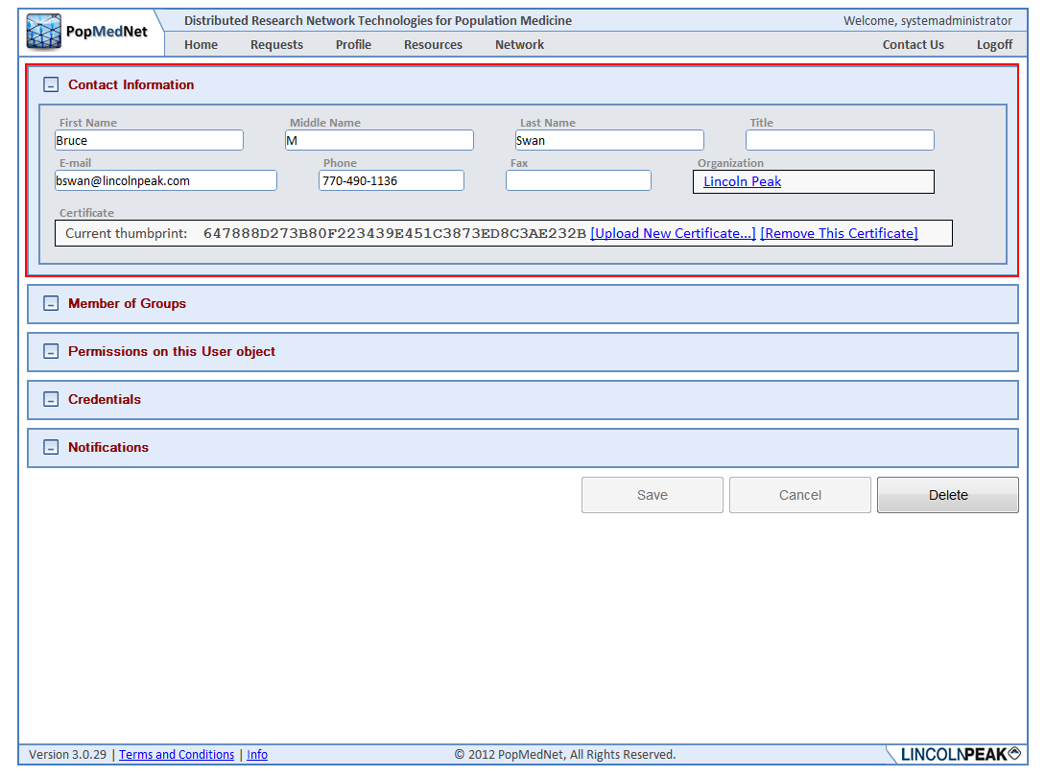

Figure : User Contact Information Panel

## Security Group Membership

Users belong to a single organization, but can take on multiple roles through membership in Security Groups. Administrators with access rights to manage user access control may select one or more security groups for which the user is a member. Membership grants the user all the rights in each security group. The following figure illustrates a list of groups the user is a member of along with the dialog used to add membership into existing groups.

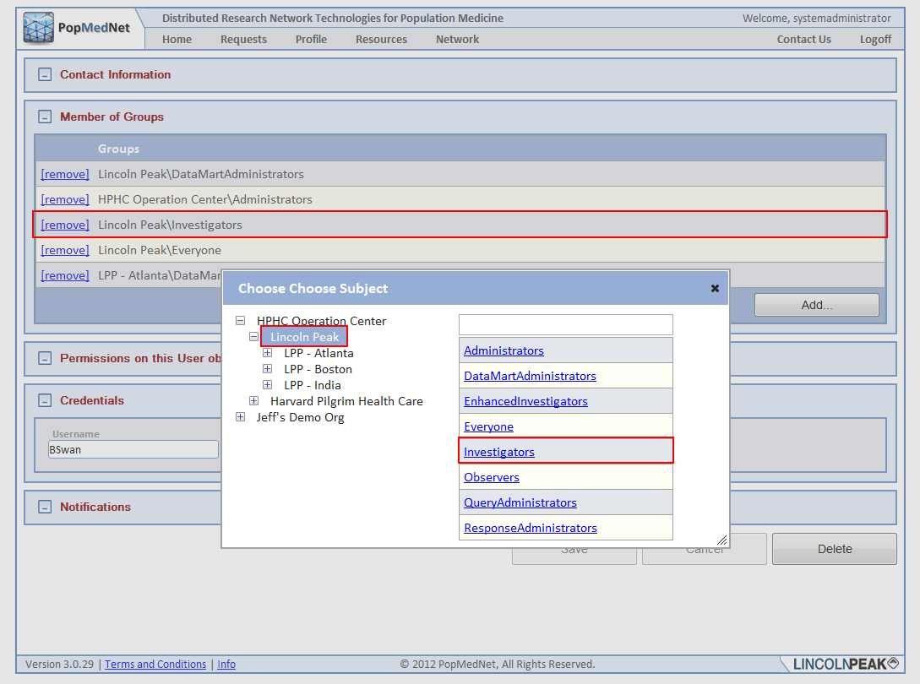

Figure : User Membership Panel

Typically, users do not have the access rights to modify their own security profile. This right is intended for either site-wide “Root” administrators or administrators who are members of the user’s organization.

## Changing your Password

The user credentials consist of a Username and Password. The username must be unique across the network. The password must be at least 9 characters long and consist of at least one number, one symbol, and at least one upper case character. Users always have the rights to modify their password at any time. Password expire periodically base on a network-wide settings described in the Network Configuration section below.

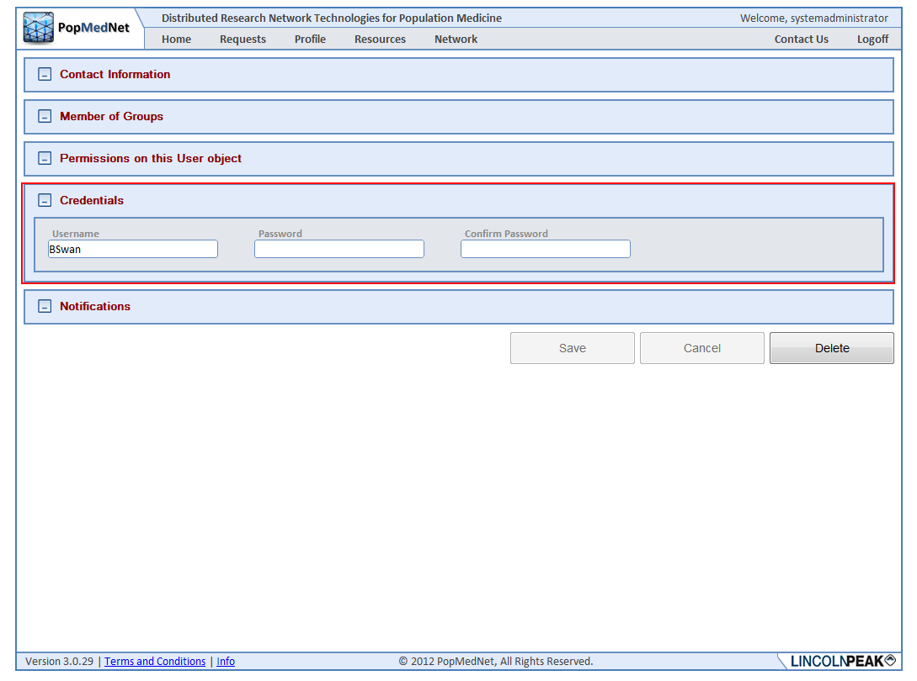

Figure : User Credentials Panel

## Receiving Notifications

Notification options allow the user to manage events that are triggered due to actions performed by the user or related to the user’s role, such as a DataMart Administrator. Users have the option of receiving notifications immediately when they are triggered, daily, weekly, or monthly. When choosing daily, weekly, or monthly, the notifications are batched together with other notifications on the same schedule in a single email.

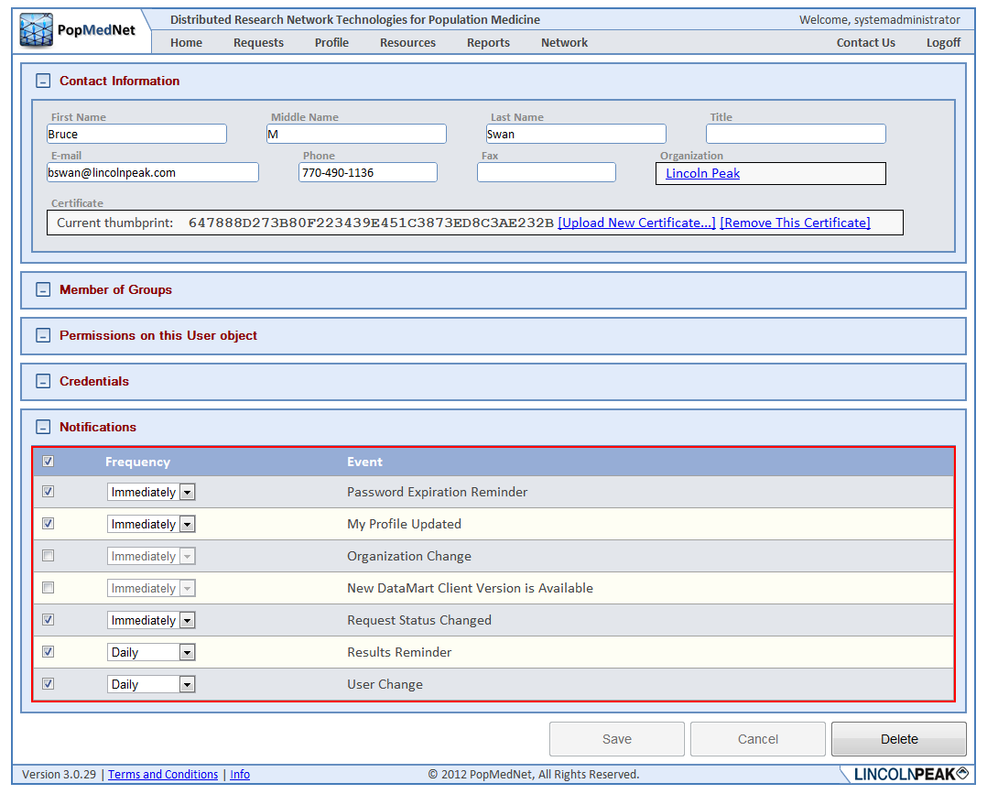

Figure : User Notifications Panel

***Note:*** *Once the user has chosen to receive notifications, no matter what the delivery frequency is selected; the notifications are displayed in the Notifications panel on the Home page.*

### Notification Event Reference

The following table lists each event that may be created in PopMedNet™ along with a description.

Table : Notifications

| Category | Event | Description |
| --- | --- | --- |
| User | Password Expiration Reminder | Notifies users when their password will be expiring |
|  | My Profile Change | Notifies you when your user profile has changed |
|  | User Change | Notifies you when a user has updated his/her user profile |
|  | New User Registration Submitted | Notifies you when a new user submits their registration form for network access |
|  | Registration Change | Notifies you when the registration status of a new user changes |
| Requests | New Request Submitted | Notifies you when a new request has been submitted to your DataMart and requires your action to process it |
|  | Request Status Changed | Notifies you when your submitted request has been on placed on hold or rejected by the DataMart administrator that you submitted the query to. |
|  | Request Reminder | Notifies you when a previously submitted request is still pending and requires your attention in order to process it |
|  | Results Reminder | Notifies you when the DataMart administrator has accepted your query and the query results have been uploaded. |
|  | Results Viewed | Notifies the DataMart Administrator when results are viewed on the Portal |
|  |  |  |
| Organization | Organization Change | Notifies you when an Organization has been added or deleted to the list of organizations that can send Queries to your DataMart |
|  |  |  |
| Group | Group Change | Notifies you when a group has been added or deleted to the list of groups allowed to send queries to your DataMart |
|  |  |  |
| DataMart | New DataMart Client Version is Available | For Datamart Administrators: Email notifications are sent to the DataMart Administrators. It alerts these administrators that the new version of the DataMart Client application is available for download. |
|  | DataMart Change | Notifies you when a DataMart has been added or deleted to the list of groups allowed to send queries to your DataMart |

# Getting Help

Once logged in, the Resource Tab offers helpful contact information, documentation, and related links, as seen below.

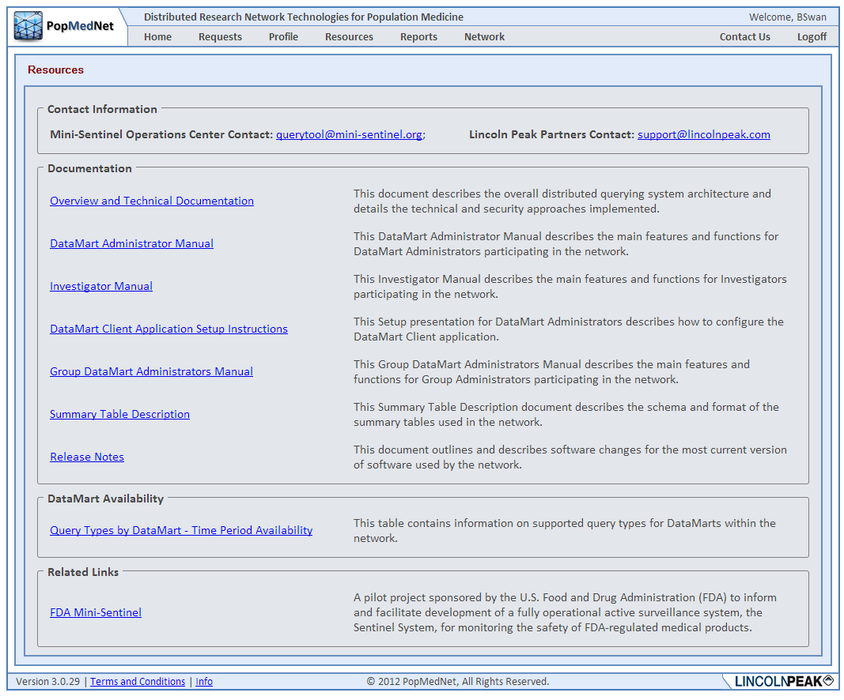

Figure : Resources Page

If you have trouble accessing the Web Portal or your user account, click on the Contact Us link and describe your issue in the email. To request additional help, contact your Network Administrator or the PopMedNet™ support staff directly.

## Development and Funding Statement

The **PopMedNet™** software application was developed as part of several contracts awarded by the Agency for Healthcare Research and Quality (AHRQ) to the HMO Research Network (HMORN) Center for Education and Research on Therapeutics (CERT) DEcIDE Center housed in the Department of Population Medicine at the Harvard Pilgrim Health Care Institute (HPHCI). Additional development was funded by AHRQ under the Scalable PArtnering Network for CER: Across Lifespan, Conditions, and Settings (SPAN) project. Additional support has been provided by The Food and Drug Administration’s Mini-Sentinel project (Contract No. HHSF223200910006I) and the US Department of Health and Human Services’ Office of the National Coordinator for Health Information Technology (ONC) MDPHnet project.

The system was developed by Lincoln Peak Partners under the direction of HPHCI.

PopMedNet™ can accommodate a wide scope of network sizes and complexity, ranging from single datasets held by only two organizations through multi-year projects encompassing dozens of organizations and dozens of data resources. Networks powered by the PopMedNet™ application can customize and brand the network as desired. The Department of Population Medicine at the Harvard Pilgrim Health Care Institute (HPHCI) led development of the system in collaboration with Lincoln Peak Partners (LPP). Lincoln Peak Partners provides support services and secure hosting for current system users, and leads development of system enhancements.

## Frequently Asked Questions

This section lists some of the most frequently asked questions.

What is the difference between Groups, Organizations, and Users?

A user is a person who has login credentials to the network Portal. Users are associated with one Organization. Organizations can be associated with one or more Groups. A Group is a set of network Organizations and can only be created by the Network Administrator. A user is typically associated with their employer organization. Organizations can be Data Partners (for example, Kaiser Permanente Colorado), federal agencies (for example, FDA, NIH), or affiliated institutions such as academic medical centers.

Users are individuals with various security groups and associated rights within the network.

What are my rights as a user and how can I change them?

Rights are mainly assigned by the Network Administrator(s). The Network Administrators can also allow certain users to assign rights within an organization or group based on the governance of the network.

Where can I get more information on the PopMedNetTM?

You may contact the Operations Center for more information:

Jeffrey Brown, PhD

Harvard Pilgrim Health Care Institute

[Jeff_brown@hphc.org](mailto:Jeff_brown@hphc.org)

[www.popmednet.org](http://www.popmednet.org)

# Uninstalling the DataMart Client

Use these steps to uninstall the DataMart Client:

1. Go to “Control Panel > Add / Remove Programs” or “Control Panel > Programs and Features” depending on which version of Windows you are using.
2. Double click “Data Mart Client” in the list of installed items displayed

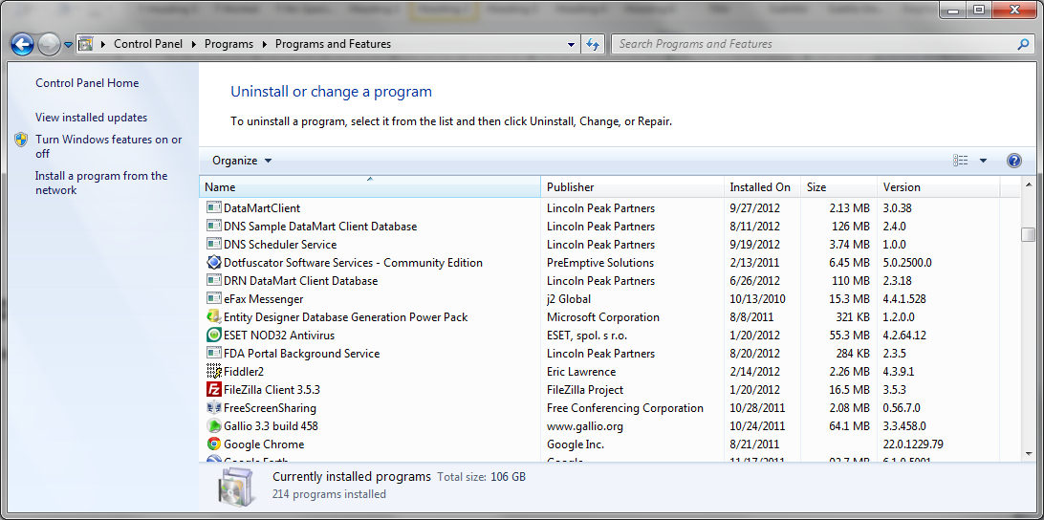

Figure : Add/Remove Programs Window

1. Click **Yes** in the pop up dialog box, “Are you sure you want to uninstall Data Mart Client?”

***Note:* *Uninstalling and installing software on operating systems like Vista might require additional authorization due to the enhanced security features (user account controls) built in to the operating system. Click “Yes” when prompted.***